  M100  ENCLOSED  LARGE FORMAT 3D PRINTER  Production-Scale 3D Printing  Without Enterprise Pricing | 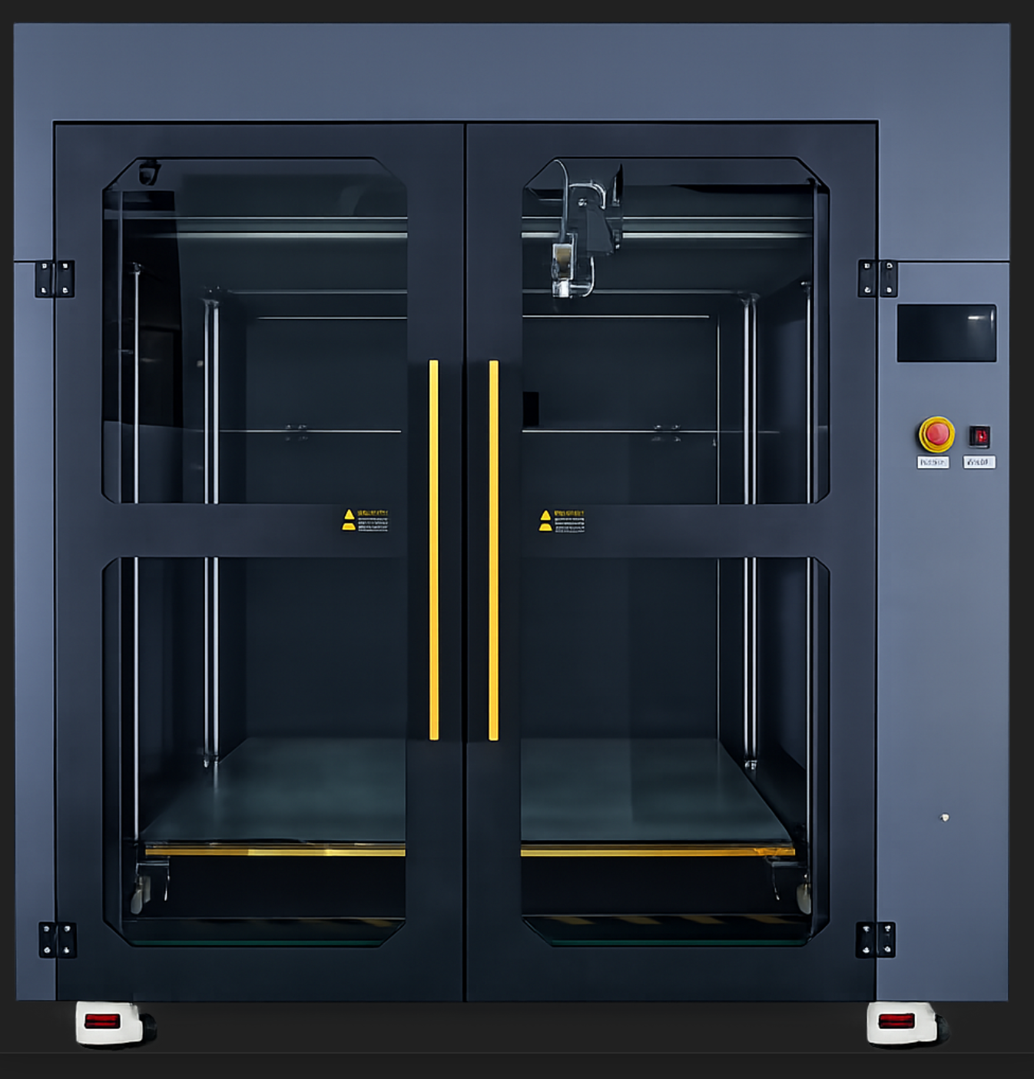
SYSTEM HIGHLIGHTS
Closed-Loop Servo Motors  Positional feedback eliminates missed steps at high speeds | Industrial Linear Rails  Full-travel rigidity across the 1m motion envelope | Klipper Firmware  Real-time kernel control with full community extensibility
Enclosed Build Chamber  Thermal stability for warp-sensitive engineering materials | Multi-Spool Filament System  1 kg and 3 kg spools; minimizes interruptions on long runs | 7" TFT Touchscreen  Direct control interface; no external PC required
1000 × 1000 × 1000 mm  BUILD VOLUME | 500 mm/s  MAX PRINT SPEED | 300°C  MAX NOZZLE TEMP

WHY THE M100?
Jaeger Technology Group LLC  1629 4th Ave SE, Suite 115 | Decatur, AL 35601  jaegertechgroup.com | Walter Jaeger  256-957-1797  wjaeger@jaegertechgroup.com

The M100 is built for organizations that have outgrown desktop-class 3D printers and need true production-scale capability. With a 1000 × 1000 × 1000 mm build volume, it enables large-format parts or full batch runs in a single print. Its servo-driven motion system and industrial linear rails deliver the torque, accuracy, and repeatability that stepper-based machines can't match. An enclosed, high-temperature chamber supports engineering materials like nylon, CF blends, and ABS. Klipper firmware keeps the system tunable as your demands grow. The M100 bridges the gap between desktop affordability and industrial performance.
Call or email us today to learn more about the M100, other machines, and our services!

FULL TECHNICAL SPECIFICATIONS

Print Technology | FDM (Fused Deposition Modeling)
Build Volume | 1000 × 1000 × 1000 mm
Machine Dimensions | 1575 × 1290 × 1600 mm
Machine Weight | 380 kg
Power Supply | 110–220V AC, 3600W
Connectivity | USB, LAN (Ethernet), Wi-Fi, USB Flash Drive
Display | 7" TFT Touchscreen (Klipper)
Max Print Speed | Up to 500 mm/s
Motion Control | Closed-loop servo motors with encoder feedback
Guide System | Industrial linear guide rails
Firmware | Klipper (open-source, real-time)
Print Accuracy | ±100 microns
Layer Thickness | 0.05 mm minimum (variable)
Nozzle Temperature | Up to 300°C
Bed Temperature | Up to 110°C
Supported Materials | PLA, ABS, PETG, PLA-CF, Nylon (PA), others ≤300°C
Filament Diameter | 1.75 mm / 3.0 mm
Nozzle Sizes Available | 0.2 / 0.3 / 0.4 / 0.6 / 0.8 / 1.0 / 1.2 up to 2.0 mm
Spool Compatibility | 1 kg and 3 kg spools (independent filament cabinet)
File Formats | STL, OBJ, G-code
Slicer Compatibility | Simplify3D, OrcaSlicer, Cura, and other Klipper-compatible slicers
OS Compatibility | Windows, macOS, Linux

Component Pictures
